Conor Hailes 000317639 lab1

Lab1A not working and is Lab1B. Lab1B working is called Lab1D

What I learned:

-Learned how to use restful and apis

-Creating scaffolding

-Database migration for visual studio

What I need to work on:

-Need to work on creating controllers

-Need to work on finding resources for help

-Need to not make small coding errors

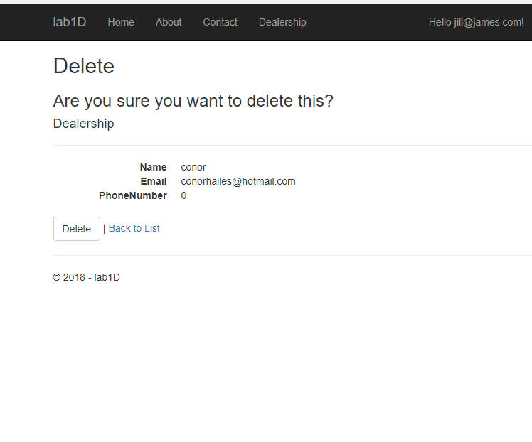

Admin delete

AdminEdit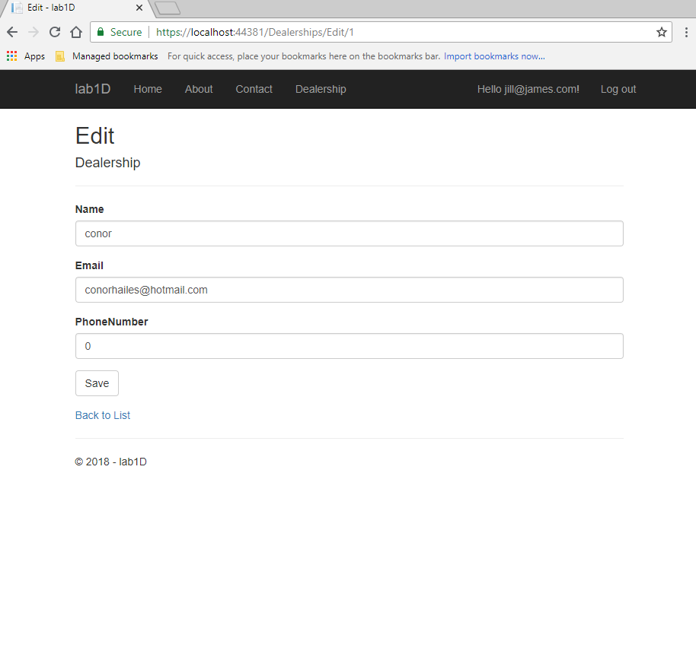

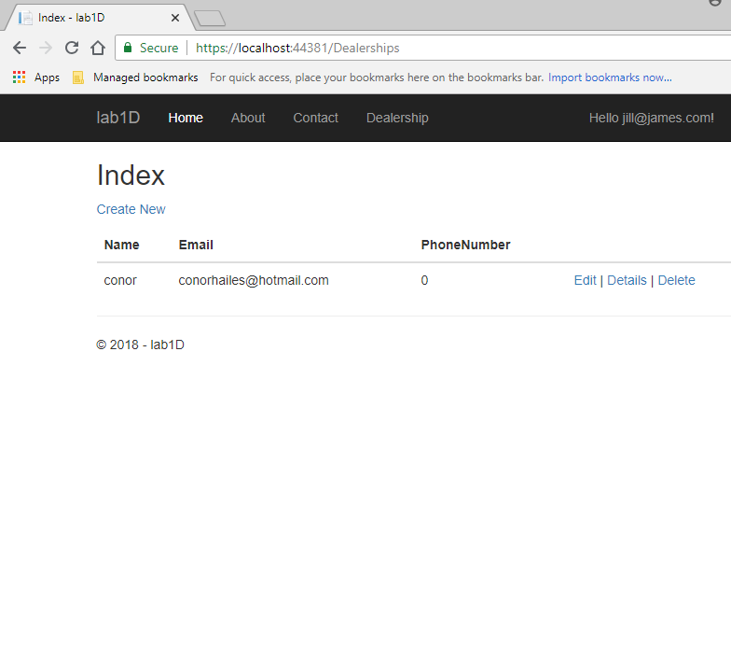

Admin get

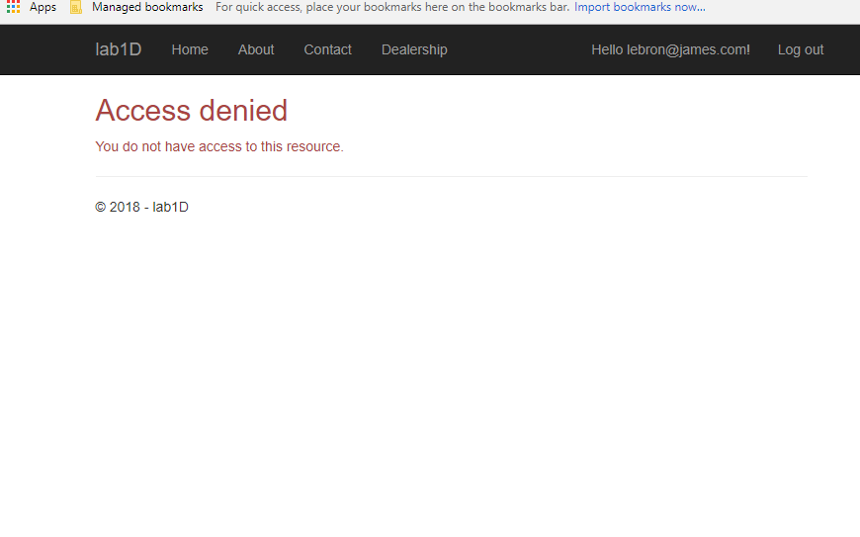

Employee create/delete/edit

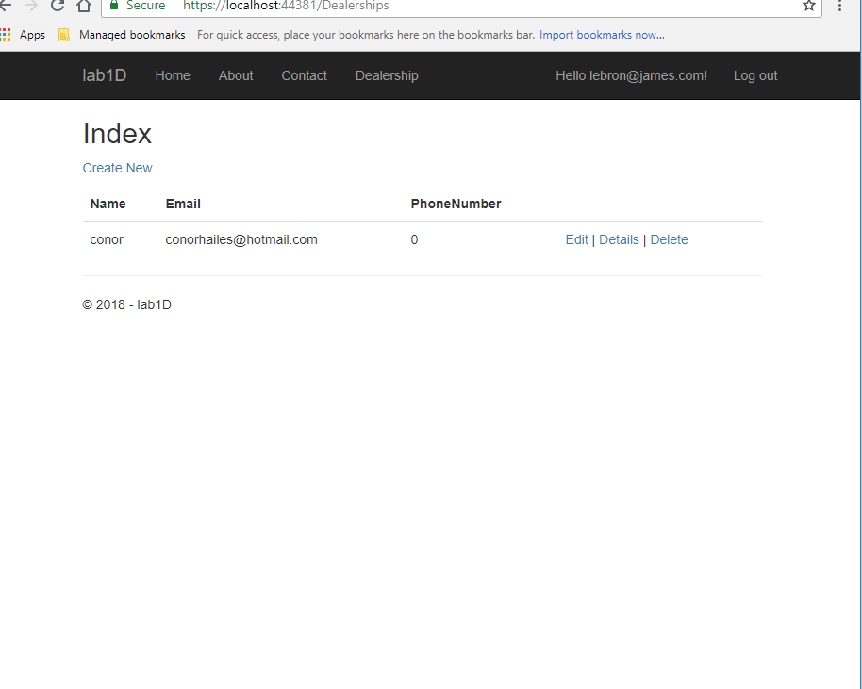

Employee get

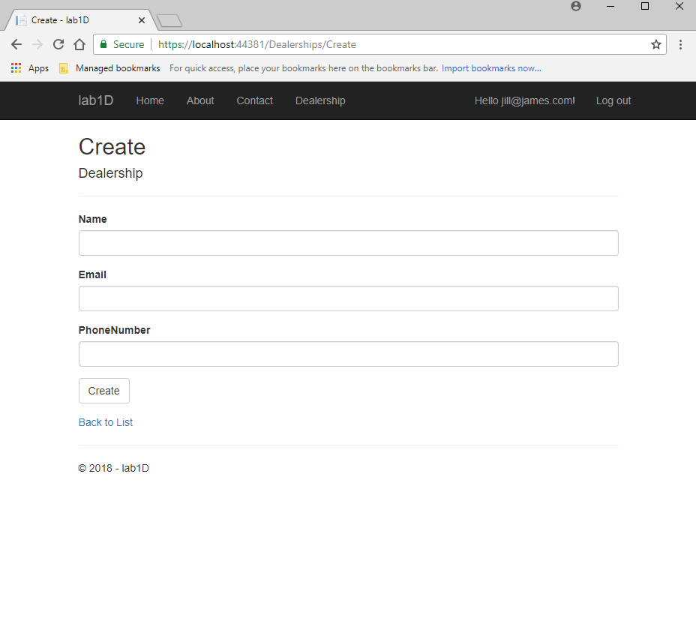

Admin Create